Social Media Toolkit: Protect Treatment Access & Positive Health Outcomes
Educate Stakeholders About the Need to Ensure Patient Access to Treatment in New Jersey

At BioNJ, our mission is to bolster medical innovation and New Jersey’s life sciences ecosystem. The discovery and development of new therapies and cures allow Patients to live longer, healthier, more productive lives – benefiting the entire healthcare system, New Jersey’s economy, and society as a whole. BioNJ has developed a resource toolkit to help Patients engage with and learn more about the policies impacting their health.

Please consider customizing and sharing the below social media content and resources with your networks to educate others on the drivers of high Patient costs in your communities and build awareness of the practices that impede treatment access for vulnerable Patient populations.

Table of Contents
Click below to view content.

- Key Resources: BioNJ Protecting Medical Innovation Campaign
- Social Media Content: Pharmacy Benefit Managers (PBMs)
- Social Media Content: The Inflation Reduction Act (IRA) & Drug Price Negotiation
- Social Media Content: ICER & Discriminatory Value Assessment Methodologies
- Social Media Content: BioNJ Drug Pricing Dictionary

Key Resources: Protect Treatment Access & Positive Health Outcomes

Patients across New Jersey are struggling to access and afford necessary treatments to manage their health and wellbeing. Some actors in the healthcare system and misguided policies threaten to exacerbate these challenges while raising out-of-pocket costs, further threatening Patient access to life-sustaining treatment. Check out the following BioNJ resources to learn more about the policies impacting Patients in New Jersey and beyond:

- RESOURCE PAGE | Value of Medical Innovation
- INFOGRAPHIC | The Impact of PBM Practices on Patients
- BLOG | Pharmacy Benefit Manager Practices: Creating Barriers to Treatment for Patients Living with Autoimmune Diseases (Molly Murray, President, Autoimmune Association)
- RESOURCE PAGE | The Impact of the Inflation Reduction Act on Patients
- BLOG | When ICER’s Health Economists Hijack the Patient-Physician Relationship (Josie Cooper, Executive Director, Alliance for Patient Access (AfPA))
- RESOURCE PAGE | BioNJ Drug Pricing Dictionary

SOCIAL MEDIA: Protect Treatment Access & Positive Health Outcomes
NOTE: All posts are customized for Twitter/X tags and character limits.

Pharmacy Benefit Managers (PBMs)

- CLICK TO POST: Pharmacy benefit managers, otherwise known as #PBMs, hinder Patients’ access to treatment in favor of their own profits. Learn more about the opaque practices of PBMs and how they impact Patients: https://bit.ly/pbminfographic

- CLICK TO POST: #PBMs frequently leave treatments for autoimmune and other chronic conditions off formularies, raising out-of-pocket costs for those Patients and putting their long-term health at risk. More from @AutoimmuneAssoc President and CEO Molly Murray: https://bit.ly/pbm-blog

- CLICK TO POST: Without greater transparency, pharmacy benefit managers (PBMs) will continue to implement practices that take advantage of Patients and threaten drug affordability while turning a profit. Learn more about #PBM practices: https://bit.ly/pbminfographic

Shareable Graphic

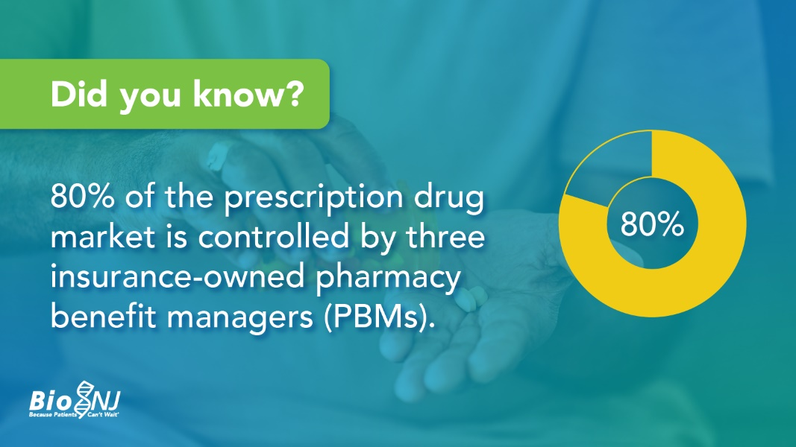
Right click and select “save as picture” to save locally to your computer.

The Inflation Reduction Act (IRA) & Medicare Drug Price Negotiation Program (MDPNP)

- CLICK TO POST: Price controls aren’t the solution to high Patient costs. The Inflation Reduction Act’s price “negotiation” policy ignores underlying causes of high prices at the pharmacy counter. More about the #IRA from @BioNJ_Org CEO, Debbie Hart: https://bit.ly/IRA-blog

- CLICK TO POST: Price “negotiation” policies in the Inflation Reduction Act (IRA) will limit Patients’ access to care – and won’t lower out-of-pocket costs. Check out these resources to learn more about the #IRA and its impact on vulnerable Patient populations: https://bit.ly/resources-IRA

- CLICK TO POST: Research shows that #IRA price-setting provisions will result in 135 less cancer drug approvals and 551 fewer HIV/AIDS clinical trials by 2039. Learn more about the threat to innovation and Patients posed by the IRA: https://bit.ly/IRA-blog

Shareable Graphic

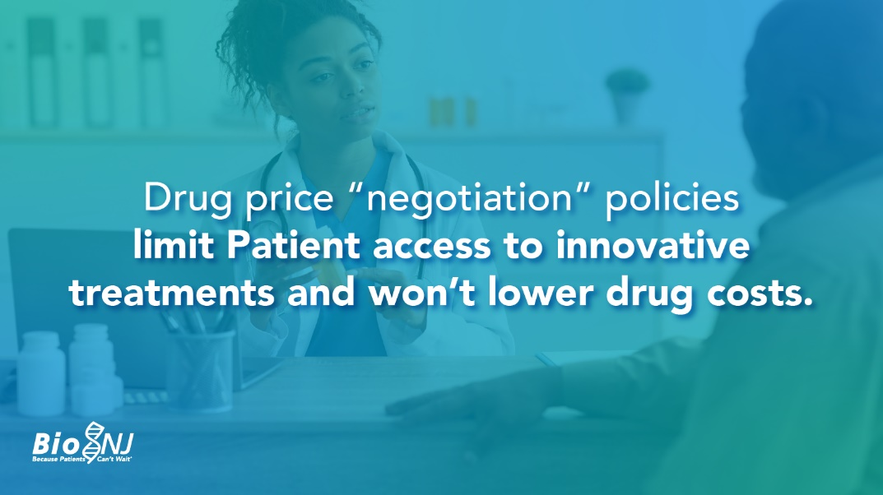
Right click and select “save as picture” to save locally to your computer.

The Institute for Clinical and Economic Review (ICER) & Discriminatory Value Assessment Methodologies

- CLICK TO POST: By using cost-effectiveness methodologies like the QALY to determine drug prices, ICER discriminates against Patients with disabilities and rare or chronic diseases and threatens their access to treatment. Learn more: https://bit.ly/ICER-infographic

- CLICK TO POST: The Quality Adjusted Life Years (QALY) methodology values the lives of young people in good health more than older adults or people with disabilities. ICER, a third-party research group, wants lawmakers to determine treatment value using the QALY: https://bit.ly/ICERblog

- CLICK TO POST: If policymakers rely on discriminatory value assessments like the QALY – an arbitrary evaluation of one year of “perfect” health – to determine treatment value, vulnerable Patient populations will be at risk of losing access to critical care: https://bit.ly/ICER-infographic

- CLICK TO POST: One-size-fits-all cost-effectiveness strategies employed by ICER undermine the valuable Patient and physician relationship and shared decision-making about the best course of treatment. More in a @BioNJ_org guest blog from @patientaccess’ Josie Cooper: https://bit.ly/ICERblog

Shareable Graphic

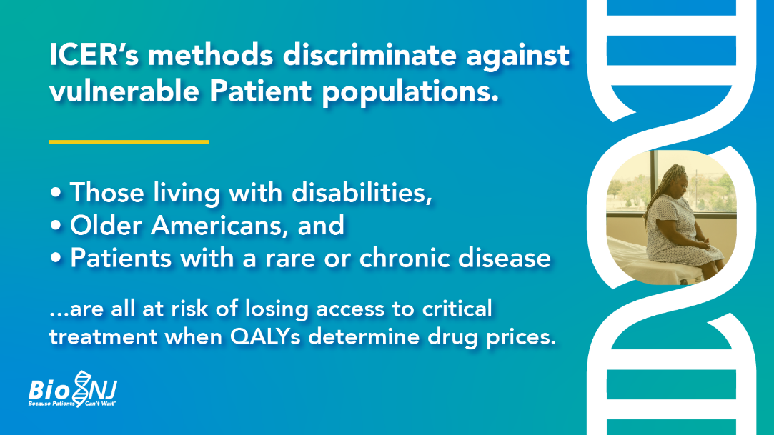
Right click and select “save as picture” to save locally to your computer.

BioNJ Drug Pricing Dictionary

- CLICK TO POST: Feeling lost in discussions about drug pricing and treatment access? BioNJ is here to help! Check out our Drug Pricing Dictionary to help you navigate those complex conversations: https://bit.ly/BioNJ_Dictionary

- CLICK TO POST: To help stakeholders across the healthcare spectrum better navigate the drug development and drug pricing environment, BioNJ has developed a Drug Pricing Dictionary featuring commonly used terms and phrases. Get started here: https://bit.ly/BioNJ_Dictionary

- CLICK TO POST: Getting medication into the hands of Patients is a complex process. No matter if you’re a Patient, advocate, or other stakeholder, you deserve a place in conversations about access. Check out our Drug Pricing Dictionary: https://bit.ly/BioNJ_Dictionary

Shareable Graphic

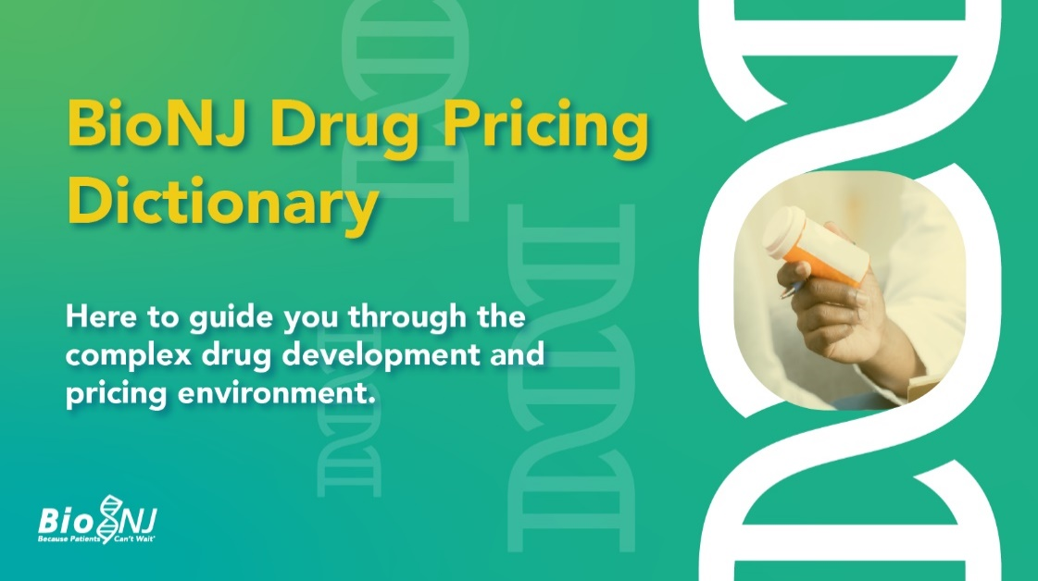
Right click and select “save as picture” to save locally to your computer.

###

